Table S1. Mean activity densities (ind./day) and ecological species traits of ground-dwelling macro-invertebrate communities from montane hay meadows in South Tyrol, Italy. The values represent means (± standard deviations) calculated from the sums of the single pitfall traps (i.e., four per plot, n = 12); for yearly values the two seasons were averaged (n = 24). Ecological species trait: rareness (rare, scattered, frequent); moisture requirement (xerophilous, mesophilous, hygrophilous, euryhygric); and ecological tolerance (i.e., habitat specificity; stenoecious, mesoecious, euryoecious). Red list status for South Tyrol is given (Gapp 1994 for Araneae; Kahlen 2018 for Coleoptera); due to missing and old data, in parenthesis additional Red List statuses from neighbouring region: Rote Liste der Weberknechte (Opiliones) Österreichs (Komposch 2009), Rote Liste und Gesamtartenliste der Spinnen (Arachnida: Araneae) Deutschlands (Blick et al. 2016).
1
(A) | Red List status |  | Rarity | Moisture requirement | Ecological tolerance | Extensive Hay Meadow (EH) |  |  |  | Intensive Hay Meadow (IH)
 | STyrol | GER |  |  |  | Spring | Autumn | Yearly Mean (± sd) |  | Spring | Autumn | Yearly Mean (± sd)
ARANEAE |  |  |  |  |  | 5.763 | 1.655 | 3.709 | (1.690) | 9.043 | 2.644 | 5.843 | (0.451)
Dysderidae |  |  |  |  |  | 0.011 | 0.011 | 0.011 | (0.019) | 0.011 | 0.011 | 0.011 | (0.010)
Dysdera ninnii Canestrini, 1868 | NT | – | scatt | eury | eury | – | – | – |  | 0.011 | – | 0.005 | (0.009)
Harpactea lepida (C. L. Koch, 1838) | LC | (LC) | freq | eury | eury | 0.011 | 0.011 | 0.011 | (0.019) | – | 0.011 | 0.006 | (0.010)
Linyphiidae |  |  |  |  |  | 0.183 | 0.011 | 0.097 | (0.085) | 0.226 | 0.103 | 0.165 | (0.081)
Agyneta affinis (Kulczyński, 1898) | – | (NT) | scatt | eury | eury | – | – | – |  | 0.086 | 0.000 | 0.043 | (0.074)
Bolyphantes kolosvaryi (Caporiacco, 1936) | LC | – | scatt | – | – | 0.011 | 0.011 | 0.011 | (0.010) | – | – | –
Centromerita bicolor (Blackwall, 1833) | LC | (LC) | freq | eury | eury | – | – | – |  | – | 0.011 | 0.006 | (0.010)
Centromerus cavernarum (L. Koch, 1872) | LC | (LC) | scatt | eury | steno | 0.011 | – | 0.005 | (0.009) | – | – | –
Ceratinella brevis (Wider, 1834) | LC | (LC) | freq | eury | eury | 0.011 | – | 0.005 | (0.009) | – | – | –
Dicymbium nigrum (Blackwall, 1834) | LC | (LC) | freq | eury | eury | 0.075 | – | 0.038 | (0.052) | 0.022 | – | 0.011 | (0.019)
Erigone atra Blackwall, 1833 | LC | (LC) | freq | eury | eury | – | – | – |  | 0.011 | – | 0.005 | (0.009)
Erigone autumnalis Emerton, 1882 | – | – | rare | – | – | 0.011 | – | 0.005 | (0.009) | – | 0.011 | 0.006 | (0.010)
Erigone dentipalpis (Wider, 1834) | LC | (LC) | freq | eury | eury | – | – | – |  | 0.032 | 0.034 | 0.033 | (0.017)
Mermessus trilobatus (Emerton, 1882) | LC | – | freq | eury | eury | 0.032 | – | 0.016 | (0.028) | – | – | –
Oedothorax apicatus (Blackwall, 1850) | LC | (LC) | freq | eury | eury | – | – | – |  | 0.043 | 0.034 | 0.039 | (0.026)
Pelecopsis parallela (Wider, 1834) | LC | (LC) | scatt | eury | eury | – | – | – |  | 0.011 | – | 0.005 | (0.009)
Saaristoa firma (O. Pickard-Cambridge, 1906) | – | (LC) | rare | hygro | meso | 0.011 | – | 0.005 | (0.009) | – | – | –
Stemonyphantes lineatus (Linnaeus, 1758) | LC |  | scatt | hygro | meso | – | – | – |  | 0.011 | – | 0.005 | (0.009)
Tenuiphantes mengei (Kulczyński, 1887) | LC | (LC) | freq | eury | eury | – | – | – |  | – | 0.011 | 0.006 | (0.010)
Tiso vagans (Blackwall, 1834) | LC | (LC) | freq | eury | eury | – | – | – |  | 0.011 | – | 0.005 | (0.009)
Trichopternoides thorelli (Westring, 1861) | – | (EN) | freq | eury | eury | 0.011 | – | 0.005 | (0.009) | – | – | –
Walckenaeria mitrata (Menge, 1868) | NT | (LC) | scatt | eury | eury | 0.011 | – | 0.005 | (0.009) | – | – | –
Tetragnathidae: Pachygnatha degeeri Sundevall, 1830 | LC | (LC) | freq | eury | eury | 0.677 | 0.011 | 0.344 | (0.440) | 3.978 | 0.138 | 2.058 | (0.535)
Araneidae: Hypsosinga albovittata (Westring, 1851) | LC | (NT) | scatt | eury | meso | 0.011 | – | 0.005 | (0.009) | – | – | –

(B) | Red List status |  | Rarity | Moisture requirment | Ecological tolerance | Extensive Hay Meadow (EH) |  |  |  | Intensive Hay Meadow (IH)
 | STyrol | GER |  |  |  | Spring | Autumn | Yearly Mean (± sd) |  | Spring | Autumn | Yearly Mean (± sd)
Lycosidae |  |  |  |  |  | 4.054 | 0.908 | 2.481 | (1.660) | 4.484 | 2.276 | 3.380 | (0.954)
Alopecosa cuneata (Clerck, 1757) | LC | (LC) | freq | xero | meso | 1.946 | – | 0.973 | (1.616) | 0.215 | – | 0.108 | (0.186)
Alopecosa pulverulenta (Clerck, 1757) | LC | (LC) | freq | eury | eury | 1.290 | – | 0.645 | (0.503) | 0.978 | – | 0.489 | (0.429)
Alopecosa sp. |  |  |  |  |  | 0.043 | 0.425 | 0.234 | (0.213) | – | 0.080 | 0.040 | (0.026)
Arctosa figurata (Simon, 1876) | VU | (VU) | rare | xero | meso | – | 0.011 | 0.006 | (0.010) | – | – | –
Pardosa palustris (Linnaeus, 1758) | LC | (LC) | freq | eury | eury | – | 0.046 | 0.023 | (0.040) | 0.301 | 0.356 | 0.329 | (0.210)
Pardosa riparia (C. L. Koch, 1833) | LC | (LC) | freq | eury | eury | – | 0.034 | 0.017 | (0.030) | – | – | –
Pardosa sp. |  |  |  |  |  | 0.215 | 0.333 | 0.274 | (0.172) | 2.591 | 1.563 | 2.077 | (0.955)
Trochosa ruricola (De Geer, 1778) | LC | (LC) | freq | eury | eury | 0.097 | – | 0.048 | (0.070) | 0.215 | 0.161 | 0.188 | (0.171)
Trochosa terricola Thorell, 1856 | LC | (LC) | freq | eury | eury | 0.452 | 0.057 | 0.255 | (0.145) | 0.172 | – | 0.086 | (0.080)
Trochosa sp. |  |  |  |  |  | 0.011 | – | 0.005 | (0.009) | 0.011 | 0.115 | 0.063 | (0.055)
Miturgidae |  |  |  |  |  | 0.011 | 0.023 | 0.017 | (0.029) | – | – | –
Zora silvestris Kulczyński, 1897 | NT | (LC) | rare | xero | meso | 0.011 | 0.011 | 0.011 | (0.019) | – | – | –
Zora sp. |  |  |  |  |  | – | 0.011 | 0.006 | (0.010) | – | – | –
Agelenidae |  |  |  |  |  | 0.043 | 0.080 | 0.062 | (0.039) ) | 0.011 | 0.023 | 0.017 | (0.017)
Eratigena agrestis (Walckenaer, 1802) | NT | (LC) | scatt | xero | meso | – | – | – |  | – | 0.011 | 0.006 | (0.010)
Inermocoelotes inermis (L. Koch, 1855) | LC | (LC) | scatt | eury | eury | 0.011 | 0.069 | 0.040 | (0.026) | – | 0.011 | 0.006 | (0.010)
Tegenaria ferruginea (Panzer, 1804) | LC | (LC) | freq | eury | eury | 0.022 | 0.000 | 0.011 | (0.009) | – | – | –
Tegenaria mirifica Thaler, 1987 | – | – | rare | – | steno | – | 0.011 | 0.006 | (0.010) | – | – | –
Tegenaria silvestris L. Koch, 1872 | LC | (LC) | freq | eury | eury | 0.011 | 0.000 | 0.005 | (0.009) | 0.011 | – | 0.005 | (0.009)
Hahniidae: Hahnia pusilla C. L. Koch, 1841 | LC | (LC) | scatt | hygro | eury | – | – | – |  | 0.011 | – | 0.005 | (0.009)
Amaurobiidae: Amaurobius obustus L. Koch, 1868 | LC | – | freq | eury | eury | – | – | – |  | 0.022 | – | 0.011 | (0.019)
Cheiracanthiidae: Cheiracanthium virescens (Sundevall, 1833) | – | (LC) | rare | xero | steno | – | – | – |  | 0.011 | – | 0.005 | (0.009)
Clubionidae: Clubiona sp. |  |  |  |  |  | 0.011 | 0.023 | 0.017 | (0.017) | – | – | –
Gnaphosidae |  |  |  |  |  | 0.237 | 0.092 | 0.164 | (0.134) | 0.043 | 0.023 | 0.033 | (0.001)
Drassodes cupreus (Blackwall, 1834) | LC | (LC) | freq | eury | meso | 0.011 | – | 0.005 | (0.009) | – | – | –
Drassodes lapidosus (Walckenaer, 1802) | LC | (LC) | freq | xero | meso | 0.011 | – | 0.005 | (0.009) | – | – | –
Drassodes pubescens (Thorell, 1856) | LC | (LC) | freq | xero | meso | 0.011 | – | 0.005 | (0.009) | – | – | –
Drassodes sp. |  |  |  |  |  | 0.075 | – | 0.038 | (0.041) | 0.011 | – | 0.005 | (0.009)
Drassyllus pusillus (C. L. Koch, 1833) | LC | (LC) | scatt | eury | meso | 0.022 | – | 0.011 | (0.019) | – | – | –
Haplodrassus sp. |  |  |  |  |  | 0.011 | – | 0.005 | (0.009) | 0.011 | – | 0.005 | (0.009)
Micaria fulgens (Walckenaer, 1802) | LC | (LC) | scatt | xero | eury | 0.022 | – | 0.011 | (0.019) | – | – | –
Zelotes latreillei (Simon, 1878) | LC | (LC) | rare | eury | eury | 0.022 | – | 0.011 | (0.019) | 0.022 | – | 0.011 | (0.009)
Zelotes petrensis (C. L. Koch, 1839) | LC | (LC) | scatt | xero | eury | 0.022 | 0.046 | 0.034 | (0.045) | – | 0.023 | 0.011 | (0.010)
Zelotes sp. |  |  |  |  |  | 0.032 | 0.046 | 0.039 | (0.043) | – | – | –

(C) | Red List status |  | Rarity | Moisture requirement | Ecological tolerance | Extensive Hay Meadow (EH) |  |  |  | Intensive Hay Meadow (IH)
 | STyrol | GER |  |  |  | Spring | Autumn | Yearly Mean (± sd) |  | Spring | Autumn | Yearly Mean (± sd)
Philodromidae |  |  |  |  |  | 0.118 | 0.276 | 0.197 | (0.130) | – | – | –
Thanatus formicinus (Clerck, 1757) | NT | (NT) | scatt | xero | meso | 0.118 | 0.253 | 0.186 | (0.135) | – | – | –
Thanatus sp. |  |  |  |  |  | – | 0.023 | 0.011 | (0.020) | – | – | –
Thomisidae |  |  |  |  |  | 0.398 | 0.207 | 0.302 | (0.089) | 0.247 | 0.069 | 0.158 | (0.058)
Ozyptila atomaria (Panzer, 1801) | LC | (LC) | freq | eury | eury | 0.043 | 0.023 | 0.033 | (0.033) | – | – | –
Ozyptila claveata (Walckenaer, 1837) | – | (LC) | rare | xero | steno | 0.011 | – | 0.005 | (0.009) | – | – | –
Ozyptila secreta Thaler, 1987 | NT | – | rare | xero | steno | – | – | – |  | – | 0.011 | 0.006 | (0.010)
Ozyptila sp. |  |  |  |  |  | – | 0.023 | 0.011 | (0.010) | 0.011 | – | 0.005 | (0.009)
Xysticus acerbus Thorell, 1872 | NT | (LC) | rare | xero | – | – | – | – |  | 0.043 | – | 0.022 | (0.019)
Xysticus bifasciatus C. L. Koch, 1837 | LC | (LC) | scatt | xero | meso | 0.054 | 0.011 | 0.033 | (0.029) | 0.011 | – | 0.005 | (0.009)
Xysticus cristatus (Clerck, 1757) | LC | (LC) | freq | eury | eury | 0.097 | 0.023 | 0.060 | (0.090) | 0.011 | – | 0.005 | (0.009)
Xysticus erraticus (Blackwall, 1834) | LC | (LC) | scatt | xero | meso | 0.129 | 0.023 | 0.076 | (0.117) | – | – | –
Xysticus kochi Thorell, 1872 | – | (LC) | freq | eury | eury | 0.011 | – | 0.005 | (0.009) | 0.097 | – | 0.048 | (0.016)
Xysticus sp. |  |  |  |  |  | 0.054 | 0.103 | 0.079 | (0.040) | 0.075 | 0.057 | 0.066 | (0.045)
Salticidae |  |  |  |  |  | 0.011 | 0.011 | 0.011 | (0.019) | – | – | –
Heliophanus sp. |  |  |  |  |  | 0.011 | 0.000 | 0.005 | (0.009) | – | – | –
Phlegra fasciata (Hahn, 1826) | LC | (LC) | freq | xero | meso | – | 0.011 | 0.006 | (0.010) | – | – | –
 | Red List status |  | Rarity | Moisture requirement | Ecological tolerance | Extensive Hay Meadow (EH) |  |  |  | Intensive Hay Meadow (IH)
 | STyrol | AUT |  |  |  | Spring | Autumn | Yearly Mean (± sd) |  | Spring | Autumn | Yearly Mean (± sd)
OPILIONES |  |  |  |  |  | 0.043 | 0.046 | 0.044 | (0.049) | – | 0.023 | 0.011 | (0.010)
Nemastomatidae: Paranemastoma quadripunctatum (Perty, 1833) | – | (NT) | scatt | hygro | steno | 0.022 | 0.000 | 0.011 | (0.009) | – | 0.000 | –
Sclerosomatidae: Astrobunus helleri (Ausserer, 1867) | – | (EN) | scatt | eury | steno | – | – | – |  | – | 0.011 | 0.006 | (0.010)
Phalangiidae |  |  |  |  |  | 0.022 | 0.046 | 0.034 | (0.058) | – | 0.011 | 0.006 | (0.010)
Mitopius morio (Fabricius, 1779) | – | (LC) | freq | eury | meso | – | 0.034 | 0.017 | (0.030) | – | 0.011 | 0.006 | (0.010)
Phalangium opilio Linnaeus, 1758 | – | (LC) | freq | eury | eury | – | 0.011 | 0.006 | (0.010) | – | – | –
Platybunus sp. |  |  |  |  |  | 0.022 | – | 0.011 | (0.019) | – | – | –
CHILOPODA |  |  |  |  |  | – | – | – |  | 0.022 | – | 0.011 | (0.019)
DIPLOPODA |  |  |  |  |  | 0.043 | 0.138 | 0.090 | (0.059) | – | 0.023 | 0.011 | (0.020)
ISOPODA |  |  |  |  |  | 0.086 | 0.011 | 0.049 | (0.033) | 0.280 | 0.184 | 0.232 | (0.201)
CAELIFERA |  |  |  |  |  | 1.656 | 0.046 | 0.851 | (0.729) | 0.172 | – | 0.086 | (0.081)
ENSIFERA |  |  |  |  |  | 0.376 | 0.011 | 0.194 | (0.059) | 0.527 | 0.011 | 0.269 | (0.372)
DERMAPTERA |  |  |  |  |  | 0.129 | 0.023 | 0.076 | (0.118) | 0.043 | 0.023 | 0.033 | (0.043)

(D) | Red List Status |  | Rarity | Moisture requirement | Ecological tolerance | Extensive Hay Meadow (EH) |  |  |  | Intensive Hay Meadow (IH)
 | STyrol | GER |  |  |  | Spring | Autumn | Yearly Mean (± sd) |  | Spring | Autumn | Yearly Mean (± sd)
COLEOPTERA |  |  |  |  |  | 0.593 | 0.621 | 0.607 | (0.189) | 1.345 | 1.678 | 1.511 | (0.695)
Carabidae |  |  |  |  |  | 0.442 | 0.299 | 0.371 | (0.174) | 0.452 | 0.425 | 0.439 | (0.223)
Abax parallelepipedus (Piller & Mitterpacher, 1783) | LC |  | scatt | hygro | eury | – | 0.034 | 0.017 | (0.017) | – | – | –
Amara aenea (DeGeer, 1774) | LC |  | freq | xero | eury | 0.011 | – | 0.005 | (0.009) | 0.054 | – | 0.027 | (0.047)
Amara communis (Panzer, 1796) | LC |  | scatt | hygro | eury | 0.022 | – | 0.011 | (0.009) | – | – | –
Amara convexior Stephens 1828 | LC |  | freq | xero | eury | 0.086 | – | 0.043 | (0.037) | – | – | –
Amara lunicollis Schiodte, 1837 | LC |  | scatt | xero | eury | 0.011 | 0.011 | 0.011 | (0.010) | 0.011 | – | 0.005 | (0.009)
Amara nigricornis C. G. Thomson 1857 | LC |  | scatt | – | steno | 0.011 | 0.011 | 0.011 | (0.019) | 0.011 | – | 0.005 | (0.009)
Amara nitida J. Sturm 1825 | LC |  | freq | – | eury | 0.032 | – | 0.016 | (0.000) | – | – | –
Amara sp. |  |  |  |  |  | 0.022 | – | 0.011 | (0.009) | – | – | –
Bembidion lampros (Herbst 1784) | LC |  | freq | – | eury | 0.011 | – | 0.005 | (0.009) | 0.011 | 0.103 | 0.057 | (0.099)
Bembidion properans (Stephens 1828) | LC |  | scatt | hygro | eury | – | – | – |  | 0.022 | – | 0.011 | (0.019)
Calathus erratus (C. R. Sahlberg, 1827) | LC |  | freq | xero | eury | – | 0.011 | 0.006 | (0.010) | – | – | –
Calathus fuscipes (Goeze, 1777) | LC |  | freq | xero | eury | – | 0.057 | 0.029 | (0.036) | – | 0.276 | 0.138 | (0.062)
Calathus melanocephalus (Linnaeus, 1758) | LC |  | freq | xero | eury | – | 0.046 | 0.023 | (0.020) | – | – | –
Carabus convexus Herbst, 1786 | LC |  | scatt | xero | eury | 0.023 | 0.000 | 0.011 | (0.020) | – | – | –
Poecilus cupreus (Linnaeus, 1758) | LC |  | freq | – | eury | 0.075 | 0.011 | 0.043 | (0.034) | 0.215 | 0.011 | 0.113 | (0.058)
Poecilus versicolor (Sturm, 1824) | LC |  | freq | – | eury | 0.022 | 0.034 | 0.028 | (0.035) | 0.108 | 0.023 | 0.065 | (0.043)
Pterostichus burmeisteri Heer, 1837 | LC |  | freq | hygro | eury | 0.118 | 0.080 | 0.099 | (0.059) | 0.011 | – | 0.005 | (0.009)
Pterostichus melanarius (Illiger, 1798) | LC |  | freq | hygro | eury | – | – | – |  | 0.011 | – | 0.006 | (0.010)
Pterostichus niger (Schaller, 1783) | LC |  | freq | hygro | eury | – | – | – |  | – | 0.011 | 0.006 | (0.010)
Staphylinidae |  |  |  |  |  | 0.151 | 0.276 | 0.213 | (0.103) | 0.602 | 0.230 | 0.416 | (0.196)
Amischa analis (Gravenhorst, 1802) | LC |  | freq | – | eury | – | – | – |  | 0.011 | 0.011 | 0.011 | (0.010)
Athetini sp. |  |  |  |  |  | – | – | – |  | 0.011 | 0.000 | 0.005 | (0.009)
Dinothenarus fossor (Scopoli, 1771) | LC |  | scatt | xero | eury | – | 0.011 | 0.006 | (0.010) | – | – | –
Gabrius toxotes Joy, 1913 | LC |  | – | – | – | 0.032 | – | 0.016 | (0.016) | – | – | –
Ischnosoma splendidum (Gravenhorst, 1806) | LC |  | scatt | hygro | eury | 0.011 | 0.011 | 0.011 | (0.010) | – | – | –
Ocypus fulvipennis Erichson, 1840 | LC |  | scatt | – | eury | 0.011 | – | 0.005 | (0.009) | – | – | –
Ocypus olens (O. F. Müller, 1764) | LC |  | rare | hygro | eury | – | 0.057 | 0.029 | (0.050) | – | 0.011 | 0.006 | (0.010)
Ocypus picipennis (Fabricius, 1792) | LC |  | scatt | xero | eury | 0.011 | 0.046 | 0.028 | (0.049) | – | – | –
Philonthus carbonarius (Gravenhorst, 1802) | LC |  | freq | – | eury | – | 0.023 | 0.011 | (0.020) | 0.011 | 0.011 | 0.011 | (0.019)
Philonthus cognatus Stephens, 1832 | LC |  | scatt | hygro | eury | 0.011 | – | 0.005 | (0.009) | 0.215 | 0.011 | 0.113 | (0.048)
Platydracus stercorarius fuscofermoratus (G. Müller, 1923) | LC |  | scatt | xero | eury | – | 0.023 | 0.011 | (0.020) | – | – | –
Sepedophilus nigripennis (Stephens, 1832) | LC |  | scatt | – | – | 0.011 | – | 0.005 | (0.009) | – | – | –
Staphylinus caesareus Cederhjelm, 1798 | LC |  | freq | hygro | eury | 0.054 | 0.011 | 0.033 | (0.001) | 0.043 | – | 0.022 | (0.025)
Staphylinus dimidiaticornis Gemminger, 1851 | LC |  | scatt | – | eury | – | 0.080 | 0.040 | (0.070) | 0.226 | 0.115 | 0.170 | (0.144)
Stenus clavicornis (Scopoli, 1763) | LC |  | freq | xero | eury | – | – | – |  | – | 0.011 | 0.006 | (0.010)
Stenus nanus Stephens, 1833 | LC |  | scatt | xero | eury | – | – | – |  | 0.032 | 0.023 | 0.028 | (0.019)
Stenus sp. |  |  |  |  |  | – | – | – |  | – | 0.011 | 0.006 | (0.010)
Tachyporus nitidulus (Fabricius, 1781) | LC |  | freq | – | eury | – | – | – |  | – | 0.011 | 0.006 | (0.010)
Tachyporus pusillus Gravenhorst, 1806 | LC |  | freq | – | – | 0.011 | – | 0.005 | (0.009) | – | – | –
Tachyporus sp. |  |  |  |  |  | – | 0.011 | 0.006 | (0.010) | 0.011 | – | 0.005 | (0.009)
Xantholinus audrasi Coiffait, 1956 | new! |  | rare | xero | steno | – | – | – |  | 0.011 | – | 0.005 | (0.009)
Xantholinus linearis (A. G. Olivier, 1795) | LC |  | freq | xero | eury | – | – | – |  | – | 0.011 | 0.006 | (0.010)
Xantholinus longiventris Heer, 1839 | LC |  | rare | hygro | eury | – | – | – |  | 0.032 | – | 0.016 | (0.016)
Curculionidae |  |  |  |  |  | – | 0.046 | 0.023 | (0.040) | 0.290 | 1.023 | 0.657 | (0.355)
FORMICIDAE |  |  |  |  |  | 0.290 | 0.885 | 0.588 | (0.425) | 1.172 | 1.828 | 1.500 | (1.115)
Camponotus ligniperda (Latreille, 1802) | – | (LC) | freq | xero | meso | – | 0.023 | 0.011 | (0.020) | – | – | –
Formica cunicularia Latreille, 1798 | – | (LC) | freq | xero | meso | 0.032 | 0.241 | 0.137 | (0.237) | – | 0.046 | 0.023 | (0.026)
Formica fusca Linnaeus, 1758 | – | (LC) | freq | xero | meso | – | 0.011 | 0.006 | (0.010) | – | 0.046 | 0.023 | (0.040)
Formica pratensis Retzius, 1783 | – | (NT) | scatt | xero | steno | – | – | – |  | 0.011 | 0.057 | 0.034 | (0.059)
Formica rufibarbis Fabricius, 1793 | – | (LC) | freq | xero | meso | – | 0.195 | 0.098 | (0.169) | – | 0.092 | 0.046 | (0.065)
Formica sanguinea Latreille, 1798 | – | (LC) | freq | xero | meso | 0.054 | 0.023 | 0.038 | (0.042) | – | – | –
Lasius flavus (Fabricius, 1782) | – | (LC) | freq | meso | eury | – | 0.011 | 0.006 | (0.010) | 0.011 | 0.046 | 0.028 | (0.026)
Lasius niger (Linnaeus, 1758) | – | (LC) | freq | meso | eury | – | – | – |  | 0.247 | 0.057 | 0.152 | (0.088)
Lasius psammophilus Seifert, 1992 | – | (NT) | freq | xero | steno | 0.043 | 0.011 | 0.027 | (0.047) | 0.419 | 0.402 | 0.411 | (0.474)
Myrmecina graminicola (Latreille, 1802) | – | (NT) | freq | xero | eury | – | – | – |  | 0.022 | – | 0.011 | (0.019)
Myrmica lobicornis Nylander, 1846 | – | (VU) | scatt | xero | steno | 0.022 | 0.011 | 0.016 | (0.017) | 0.032 | 0.149 | 0.091 | (0.099)
Myrmica lonae Finzi, 1926 | – | (VU) | scatt | hygro | eury | 0.022 | 0.023 | 0.022 | (0.039) | 0.032 | 0.046 | 0.039 | (0.020)
Myrmica rubra (Linnaeus, 1758) | – | (LC) | scatt | hygro | eury | – | – | – |  | – | 0.069 | 0.034 | (0.060)
Myrmica scabrinodis Nylander, 1846 | – | (NT) | freq | meso | eury | 0.086 | 0.322 | 0.204 | (0.223) | 0.398 | 0.805 | 0.601 | (0.756)
Myrmica vandeli Bondroit, 1920 | – | (EN) | scatt | hygro | steno | – | 0.011 | 0.006 | (0.010) | – | 0.011 | 0.006 | (0.010)
Tapinoma subboreale Seifert, 2012 | – | (VU) | freq | xero | meso | 0.032 | – | 0.016 | (0.028) | – | – | –

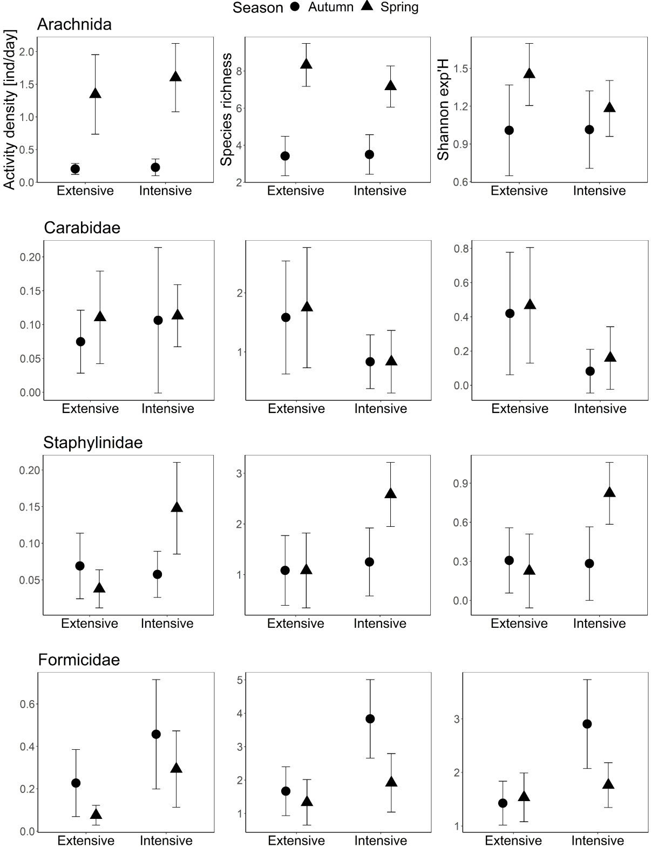
Figure S1. The mean (and 95% confidence interval) activity density as individuals per day, species richness and exponential Shannon diversity of selected predatory ground-dwelling arthropods (Arachnida, Carabidae, Staphylinidae, and Formicidae) from extensively and intensively managed montane hay meadows in South Tyrol, Italy. Significant effect of management was detected for Carabidae for species richness (LMM: Chi² = 4.39 p = 0.037) and diversity (LMM: Chi² = 5.77 p = 0.016) and Staphylinidae for species richness (LMM: Chi² = 5.01 p = 0.024) and species diversity (LMM: Chi² = 4.62 p = 0.032).
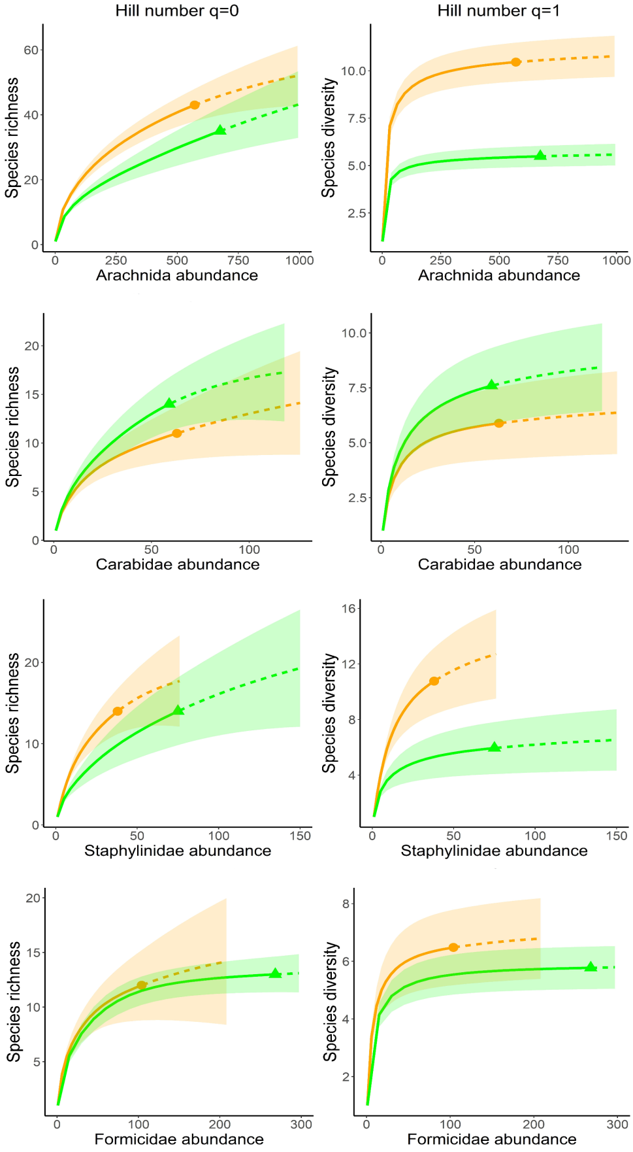
Figure S2. Abundance-based accumulation curves for selected predatory ground-dwelling arthropods (Arachnida, Carabidae, Staphylinidae and Formicidae) based on Hill numbers N0 and N1 confronting extensively and intensively managed montane hay meadows in South Tyrol, Italy.

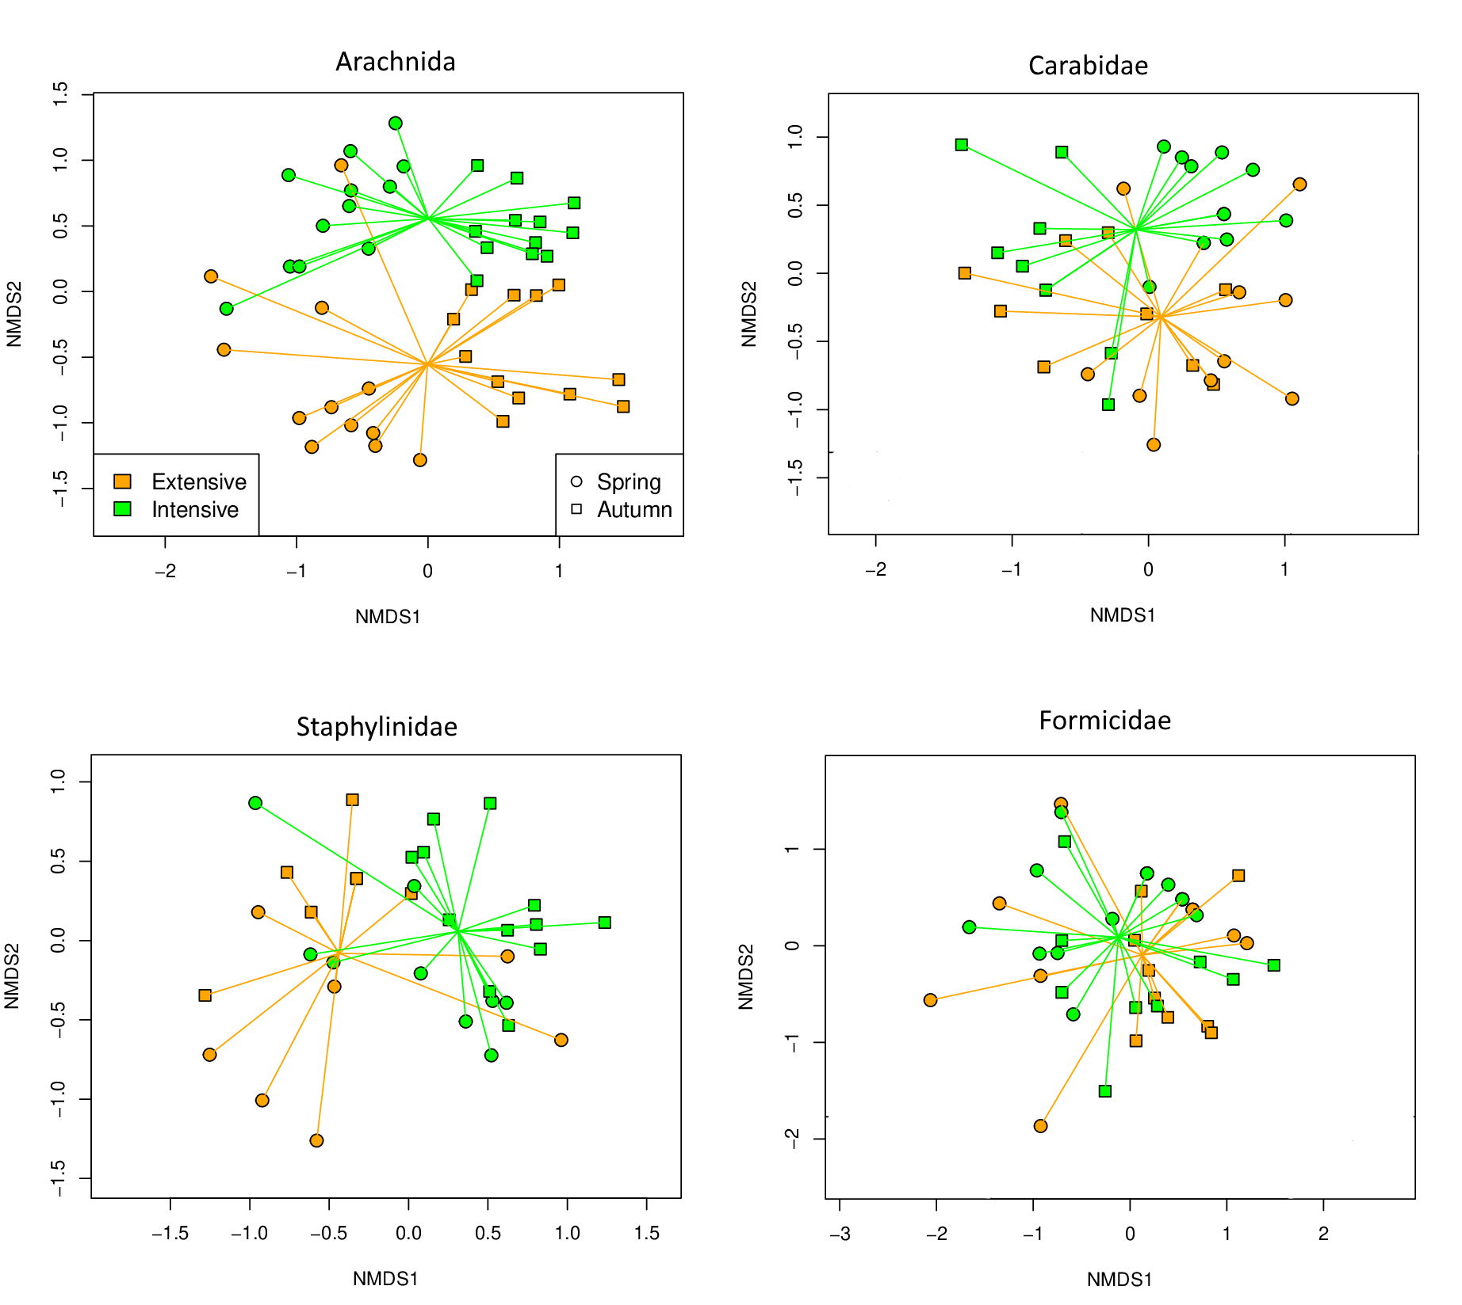
Figure S3. Non-metric multidimensional scaling (NMDS) of selected predatory ground-dwelling arthropods (Arachnida, Carabidae, Staphylinidae, and Formicidae) confronting extensively and intensively managed montane hay meadows in South Tyrol, Italy. Each data point represents one pitfall trap. The spider web centres are the weighted centroids of each management type.

16

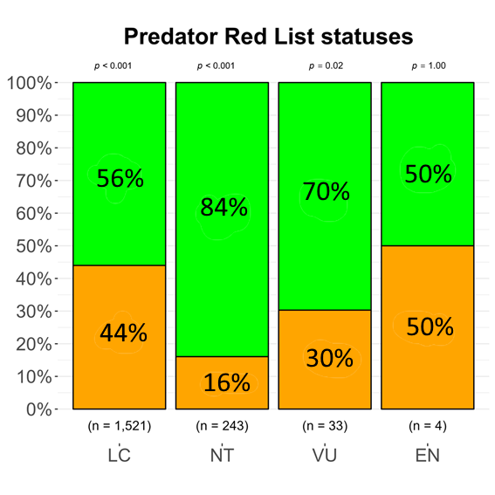
Figure S4. Proportions and χ²-test results for the Red List statuses of ground-dwelling predatory arthropods (Arachnida, Carabidae, Staphylinidae, Formicidae) from extensively and intensively managed hay meadows in South Tyrol, Italy.

